
HEAD OF DEPARTMENT
Professor Dr. Shahid Ali
SENIOR REGITRAR ADMIN REGISTRAR
Dr. Azeem Hamdani Dr Kishmala Kirn
POST GRADUATE RESIDENTS
Dr Ameer Hamza Dr Mushahid Abbas
Dr Danish Rehman Dr Farwa Shaukat
Dr Rimsha Raza Dr Nimra
Dr Afnan

MEDICAL OFFICERS
Dr. Muhammad Huzaifa( MCPS) Dr. Tooba Bashir

Studyguide ENT Head &Neck Surgery

MODULAR INTEGRATED CURRICULUM 2K23
4TH Year

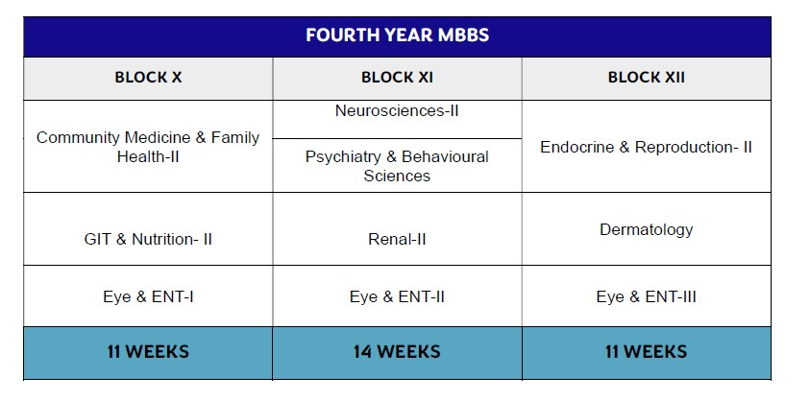



Duration: 11 Weeks
No of Modules: 03
Module 24: Community Medicine & Family Health-II
Module 25: GIT & Nutrition-II
Module 26: EYE & ENT-I

BLOCK 10 MANAGEMENT TEAM
Head of Department | Prof. Dr Shahid Ali
Senior Registrar | Dr. Syed Azeem
BLOCK COORDINATOR | Dr. Danish Rehman

MODULE RATIONALE
The inclusion of module related to otorhinolaryngology in the undergraduate medical curriculum is imperative to ensure that future physicians acquire the essential knowledge and skills to diagnose and manage both common and potentially serious otorhinolaryngological conditions. Such training not only contributes to improved patient care but also alleviates the burden on specialized ENT (ear, nose, throat) services, thereby enhancing overall healthcare delivery and efficiency. The objective of this module is to outline the essential knowledge, skills, attitudes, and competencies in otorhinolaryngology that must be attained during undergraduate medical training.
MODULE OUTCOMES
- Explain the pathophysiology and clinical features of common ear, nose, and throat disorders.
- Identify and diagnose prevalent otorhinolaryngological conditions through history-taking and clinical evaluation.
- Perform basic otorhinolaryngological examination techniques competently.
- Initiate appropriate first-line management for common ENT conditions and determine indications for timely referral to specialist care.
- Recognize and provide initial stabilization for otorhinolaryngological emergencies, such as airway obstruction and severe epistaxis, followed by appropriate referral.
- Communicate effectively with patients regarding ENT conditions, management options, and preventive strategies, ensuring clarity and patient-centered care.
- Demonstrate professionalism, ethical conduct, and a respectful attitude in the care of patients with otorhinolaryngological conditions
SUBJECTS INTEGRATED IN THE MODULE
- Anatomy
- Physiology
- Pathology
- Pharmacology
- Oncology
- Forensic Medicine

LEARNING OUTCOMES
ENT-I (EAR)
CODE | SPECIFIC LEARNING OUTCOMES | INTEGRATING DISCIPLINE | TOPIC
ENT1-  Ear-001 | Classify the types of hearing loss.  Explain the pathophysiological mechanisms underlying hearing loss.  Differentiate between conductive and sensorineural hearing loss.  Describe the indications, benefits, and limitations of hearing implants. | ENT | Hearing Loss
ENT1-  Ear-002 | Diagnose Perichondritis of pinna on basis of clinical features and plan its management. | ENT | Diseases of the  External Ear
ENT1-  Ear-002 | Define and classify Otitis externa.  Describe the clinical presentation.  Plan management. | ENT | Diseases of the  External Ear
ENT1-  Ear-002 | Describe the etiology, clinical presentation, and treatment of Otomycosis.  Differentiate Otomycosis from other causes of otitis externa. | ENT | Diseases of the  External Ear
ENT1-  Ear-002 | Describe the composition of ear wax.  Diagnose cerumen impaction based on clinical presentation.  Outline the treatment options and precautions.  Enlist complications associated with cerumen removal. | ENT | Diseases of the  External Ear
ENT1-  Ear-002 | Diagnose foreign bodies impaction in the ear based on clinical presentation.  Enlist the complications.  Outline the methods for removal of foreign bodies in the ear. | ENT | Diseases of the  External Ear
ENT1-  Ear-002 | Describe the etiology, clinical presentation, and treatment of auricular hematoma. | ENT | Diseases of the  External Ear

Identify frostbite of the ear based on clinical presentation with its management plan.
Describe the etiology, clinical presentation, and treatment of lacerations and avulsion injuries of the pinna.
ENT1-  Ear-003 | Enlist the etiological and risk factors of Acute Otitis Media.  Diagnose acute otitis media based on clinical presentation.  Outline the treatment plan.  Enlist the complications. | ENT | Diseases of the  Middle Ear
ENT1-  Ear-003 | Describe the etiology and clinical presentation of Chronic Otitis Media.  Outline the management strategies.  Enlist the potential complications.  Outline the management plan of facial paralysis in otitis media. | ENT | Diseases of the  Middle Ear
ENT1-  Ear-003 | Explain the pathophysiology and risk factors of Otosclerosis.  Formulate differential diagnosis.  Outline the management plan. | ENT | Diseases of the  Middle Ear
ENT1-  Ear-004 | Enlist the causes of pre-lingual Sensorineural Hearing Loss.  Explain the clinical presentation and diagnostic approach.  Plan medical, rehabilitative, and surgical management. | ENT | Diseases of  Inner Ear
ENT1-  Ear-004 | Explain the pathophysiology and clinical features of Benign Paroxysmal Positional Vertigo (BPPV).  Outline management, including repositioning maneuvers and patient counseling. | ENT | Diseases of  Inner Ear
ENT1-  Ear-004 | Describe the etiology and clinical presentation of vestibular neuronitis.  Differentiate vestibular neuronitis from central causes of vertigo. | ENT | Diseases of  Inner Ear

 | Discuss management plan.
Describe the etiology and predisposing factors of Meniere’s disease.
Describe the characteristic signs and symptoms.
Outline the medical and surgical management options. Discuss the long-term impact of Meniere’s disease on hearing and quality of life.
Describe the etiology and risk factors of Presbyacusis. Diagnose based on clinical presentation.
Outline management plan including preventive measures.
Describe the etiology and risk factors of noise-induced hearing loss (NIHL).
Identify the clinical presentation and audiometric findings of NIHL.
Outline management plan including prevention.
ENT1-  Ear-005 | Enlist the common ototoxic drugs.  Describe the mechanism of ototoxicity.  Identify clinical presentation of ototoxic hearing loss. Outline strategies for monitoring, prevention, and management of ototoxicity. | ENT/ Pharmacology | Ototoxic hearing loss
ENT1-  Ear-006 | Identify clinical features of Glomus tumor.  Enlist investigations.  Discuss management options. | ENT | Glomus tumor
ENT1-  Ear-006 | Describe clinical features of temporal bone trauma.  Enlist its possible complications.  Outline relevant investigations and initial management plan. | ENT | Temporal bone trauma
ENT1-  Ear-007 | Describe causes and clinical features of facial nerve palsy.  Outline management plan.  Identify potential complications and prognostic factors of facial nerve palsy. | ENT | Facial Nerve  Palsy
ENT1-  Ear-008 | Describe following surgical procedures used in treatment of ear diseases and mention their indications.  i. Myringotomy ii. Myringoplasty iii. Tympanoplasty iv. Cortical mastoidectomy  v. Modified radical mastoidectomy vi. Radical Mastoidectomy | ENT | Surgical  Procedures of  Ear


Duration: 11 Weeks
No of Modules: 04
Module 27: Neurosciences-II
Module 28: Psychiatry & Behavioral Sciences
Module 29: Renal-II
Module 30: EYE & ENT-II

BLOCK 11 MANAGEMENT TEAM
Head of Department | Prof. Dr Shahid Ali
Senior Registrar | Dr. Syed Azeem
BLOCK COORDINATOR | Dr. Danish Rehman

MODULE RATIONALE
The inclusion of module related to otorhinolaryngology in the undergraduate medical curriculum is imperative to ensure that future physicians acquire the essential knowledge and skills to diagnose and manage both common and potentially serious otorhinolaryngological conditions. Such training not only contributes to improved patient care but also alleviates the burden on specialized ENT (ear, nose, throat) services, thereby enhancing overall healthcare delivery and efficiency. The objective of this module is to outline the essential knowledge, skills, attitudes, and competencies in otorhinolaryngology that must be attained during undergraduate medical training.
MODULE OUTCOMES
- Explain the pathophysiology and clinical features of common ear, nose, and throat disorders.
- Identify and diagnose prevalent otorhinolaryngological conditions through history-taking and clinical evaluation.
- Perform basic otorhinolaryngological examination techniques competently.
- Initiate appropriate first-line management for common ENT conditions and determine indications for timely referral to specialist care.
- Recognize and provide initial stabilization for otorhinolaryngological emergencies, such as airway obstruction and severe epistaxis, followed by appropriate referral.
- Communicate effectively with patients regarding ENT conditions, management options, and preventive strategies, ensuring clarity and patient-centered care.
- Demonstrate professionalism, ethical conduct, and a respectful attitude in the care of patients with otorhinolaryngological conditions
SUBJECTS INTEGRATED IN THE MODULE
Anatomy
Physiology
Pharmacology
Forensic Medicine


97

C2K23 Year-04

LEARNING OUTCOMES
ENT-II (NOSE)
CODE | SPECIFIC LEARNING OUTCOMES | INTEGRATING DISCIPLINE | TOPIC
ENT2-  Nose-  001 | Identify important structures in the surgical anatomy of the nose that require care during surgery.  Describe the surgical anatomy of the paranasal sinuses, emphasizing relations with vital structures. | ENT/Anatomy/  Physiology | Surgical anatomy and physiology of nose and  paranasal sinuses
ENT2-  Nose-  001 | Describe mucociliary clearance and its role in sinus health and postoperative outcomes.  Correlate surgical anatomy and physiology with common clinical conditions (e.g., epistaxis, sinusitis) and their surgical management. | ENT/Anatomy/  Physiology
ENT2-  Nose-  002 | Describe the clinical features, management, and complications of following infections.  i. Boil ii. Cellulitis iii. Vestibulitis  Diagnose on basis of the clinical features, outline management plan, and discuss the complications of following:  i. Foreign bodies in nose ii. Maggots nose  iii. Rhinolith | ENT | Diseases of the  External Nose and Nasal  Vestibule
ENT2-  Nose-  003 | Differentiate between simple snoring and obstructive sleep apnea syndrome (OSAS).  Explain the underlying mechanisms and causes.  Describe the clinical presentation and complications.  Identify the diagnostic methods and investigations.  Discuss the various treatment options. | ENT | Snoring and Sleep Apnea
ENT2-  Nose-  004 | Identify the etiology of Deviated Nasal Septum (DNS) and its types.  Describe clinical presentation. | ENT | Nasal Septum  Deformities

Enlist the surgical procedures to correct DNS.
Identify complications of nasal septal surgery.
Enlist the causes of Septal Perforation.
Describe its clinical presentation.
Enlist investigations to rule out cause of septal perforation.
Outline the management plan.
Enlist the causes of Septal Abscess.
Identify its clinical presentation and complications.
Outline the treatment of septal abscess.
ENT2-  Nose-  005 | Define and classify Rhinitis.  Describe clinical features of infective rhinitis with management.  Describe the clinical features of following types of noninfective rhinitis and their management:  i. Allergic Rhinitis ii. Vasomotor Rhinitis iii. Atrophic Rhinitis iv. Hypertrophic Rhinitis  v. Rhinitis Medicamentosa | ENT | Rhinitis  (Infective and  Non-infective)
ENT2-  Nose-  006 | Define Sinusitis.  Describe clinical presentation.  Enlist investigations.  Describe the treatment of acute and chronic Sinusitis. Enlist the surgical procedures done in case of chronic Sinusitis.  Identify complications of Sinusitis. | ENT | Infections of the  Paranasal  Sinuses
ENT2-  Nose-  007 | Define Nasal Polyp.  Describe its etiology and clinical features.  Differentiate between Antro choanal and ethmoidal polyps.  Outline the management plan. | ENT | Nasal Polyps
ENT2-  Nose-  008 | Enlist the causes of Epistaxis.  Describe its clinical features.  Outline initial management and preventive strategies. | ENT | Epistaxis

ENT2-  Nose-  009 | Identify clinical features of maxillofacial trauma.  Enlist necessary investigations.  Outline steps for initial management.  Discuss the management of the following:  i. Fracture nasal bone ii. Mandibular fracture iii. Maxillary bone fracture iv. Zygomatic fracture  v. Orbital blowout fracture  Enlist the etiology of CSF Rhinorrhoea.  Describe its clinical presentation.  Outline investigations and management plan.  Describe the medico-legal implications of maxillofacial trauma, including proper documentation, reporting requirements, and preservation of evidence for legal purposes. (Integrate with Forensic Medicine-see annexure A) | ENT/Forensic medicine | Facial Trauma  (Maxillofacial)
ENT2-  Nose-  010 | Describe the clinical features and ENT manifestations of Nasal Tuberculosis.  Explain the pathology, clinical presentation, and complications of leprosy involving the nose.  Discuss the clinical features, diagnosis, and management of invasive Aspergillosis of the paranasal sinuses.  Describe the presentation, rapid progression, and surgical importance of Mucormycosis.  Explain the nasal and systemic manifestations of Wegener’s granulomatosis and its diagnostic approach.  Describe ENT features of Systemic Lupus  Erythematosus with emphasis on nasal involvement. Discuss the clinical features and diagnostic findings of Sarcoidosis affecting the nose and paranasal sinuses. | ENT | Granulomatous  Disorders of  Nose &  Paranasal  Sinuses
ENT2-  Nose-  011 | Describe the pathology, clinical features, and surgical importance of Inverted Papilloma.  Explain the clinical presentation, diagnosis, and management principles of Transitional cell carcinoma of the sinonasal region.  Correlate the surgical anatomy of the sinonasal region with the spread and complications of these neoplasms. | ENT/Pathology | Sino nasal neoplasm

MODULE RATIONALE
The inclusion of module related to otorhinolaryngology in the undergraduate medical curriculum is imperative to ensure that future physicians acquire the essential knowledge and skills to diagnose and manage both common and potentially serious otorhinolaryngological conditions. Such training not only contributes to improved patient care but also alleviates the burden on specialized ENT (ear, nose, throat) services, thereby enhancing overall healthcare delivery and efficiency. The objective of this module is to outline the essential knowledge, skills, attitudes, and competencies in otorhinolaryngology that must be attained during undergraduate medical training.
MODULE OUTCOMES
- Explain the pathophysiology and clinical features of common ear, nose, and throat disorders.
- Identify and diagnose prevalent otorhinolaryngological conditions through history-taking and clinical evaluation.
- Perform basic otorhinolaryngological examination techniques competently.
- Initiate appropriate first-line management for common ENT conditions and determine indications for timely referral to specialist care.
- Recognize and provide initial stabilization for otorhinolaryngological emergencies, such as airway obstruction and severe epistaxis, followed by appropriate referral.
- Communicate effectively with patients regarding ENT conditions, management options, and preventive strategies, ensuring clarity and patient-centered care.
- Demonstrate professionalism, ethical conduct, and a respectful attitude in the care of patients with otorhinolaryngological conditions
SUBJECTS INTEGRATED IN THE MODULE
Anatomy
Physiology
Pathology
Pharmacology
Oncology
Forensic Medicine



Duration: 10 Weeks
No of Modules: 03
Module 31: Endocrinology and Reproduction-II
Module 32: Dermatology
Module 33: EYE & ENT-III
BLOCK 12 MANAGEMENT TEAM
Head of Department | Prof. Dr Shahid Ali
Senior Registrar | Dr. Syed Azeem
BLOCK COORDINATOR | Dr. Danish Rehman

LEARNING OUTCOMES
ENT-III (THROAT)
CODE | SPECIFIC LEARNING OUTCOMES | INTEGRATING DISCIPLINE | TOPIC
ENT-  Throat-  001 | Enlist cystic lesions of oral cavity.  Discuss differential diagnosis of following cystic lesions of oral cavity and their treatment  i. Mucoceles ii. Ranula iii. Dermoid cyst | ENT | Cystic lesions of oral cavity
ENT-  Throat-  002 | Identify the clinical features and order investigations of sialadenitis, sialolithiasis, and sialectasis.  Outline the treatment plan for sialadenitis, sialolithiasis, and sialectasis | ENT | Salivary Gland  Disorders
ENT-  Throat-  003 | Describe the etiology and risk factors of aphthous ulcer.  Explain the morphological features of aphthous ulcer.  Differentiate aphthous ulcers from other oral ulcers.  Outline the management plan of aphthous ulcer. | ENT | Aphthous ulcer
ENT-  Throat-  004 | Describe the etiology, predisposing factors, and clinical features of Vincent’s angina.  Differentiate Vincent’s angina from diphtheria.  Discuss the diagnostic approach, including clinical examination and smear findings.  Enlist the complications associated with Vincent’s angina.  Outline the management plan of Vincent’s angina. | ENT | Vincent’s angina
ENT-  Throat-  005 | Describe the clinical features, differential diagnosis, and management of leukoplakia and erythroplakia of the tongue. | ENT | Leukoplakia and  erythroplakia
ENT-  Throat-  006 | Describe the surgical anatomy of the nasopharynx, oropharynx, and hypopharynx.  Identify important anatomical relations and structures at risk during surgery. | ENT/Anatomy | Surgical anatomy and  physiology of pharynx

ENT-  Throat-  007 | Describe predisposing factors and the clinical presentations and treatment of acute & chronic pharyngitis. | ENT | Pharyngitis
ENT-  Throat-  008 | Enumerate the disorders that may present with a white patch or membrane over the tonsils.  Identify the clinical features and order investigations required for diagnosis of diphtheria.  Discuss the possible complications resulting from diphtheria and its prevention.  Plan the management of faucial diphtheria. | ENT/Paediatrics | Membranous pharyngitis/  Diphtheria
ENT-  Throat-  009 | Describe the clinical features of acute and chronic tonsillitis.  Outline the treatment of acute & chronic tonsillitis.  Enlist the indications and contraindications of tonsillectomy.  Discuss the pre-operative preparation, post-operative care, and management of complications in tonsillectomy.  Identify the clinical signs and symptoms of peritonsillar abscess and outline its management | ENT | Tonsillitis
ENT-  Throat-  010 | Enlist the etiology of adenoid hypertrophy.  Identify the clinical features and order the investigations required for diagnosis of adenoiditis.  Describe the management of adenoiditis.  Enlist the indications, contraindications and complications of adenoidectomy | ENT | Adenoids
ENT-  Throat-  011 | Describe the clinical features, investigations, and surgical management of juvenile nasopharyngeal angiofibroma.  Explain the clinical presentation, diagnostic work-up, and treatment of nasopharyngeal carcinoma. | ENT/Oncology | Neoplasms of nasopharynx
ENT-  Throat-  012 | Define Plummer-Vinson syndrome and its classical triad. | ENT/Pathology | Plummer-Vinson syndrome

Explain the pathophysiological role of iron deficiency in the development of mucosal atrophy and esophageal webs.
Describe the clinical features and possible complications of PVS.
Outline the management plan of PVS.
ENT-  Throat-  013 | Describe the causes, clinical features, and management of acute laryngitis.  Discuss the etiology, clinical features, and treatment of chronic laryngitis. | ENT | Acute and chronic laryngitis
ENT-  Throat-  014 | Describe the etiology and pathophysiology of acute laryngo-tracheobronchitis.  Identify its clinical.  Differentiate from other causes of stridor.  Outline the management plan. Describe the emergency measure in acute laryngotracheobronchitis. | ENT/Paediatrics | Stridor/Croup
ENT-  Throat-  015 | Enumerate the causes of vocal cord paralysis.  Identify the clinical features of unilateral and bilateral abductor paralysis.  Diagnose the unilateral and bilateral adductor paralysis.on basis of clinical features.  Discuss the principles of management of vocal cord paralysis.  Explain the role of speech therapy in the management of vocal cord paralysis. | ENT | Hoarseness - vocal cord paralysis
ENT-  Throat-  016 | Describe the etiology of vocal nodules.  Explain the pathophysiology of vocal nodules.  Identify the clinical features of vocal nodules.  Outline the management principles of vocal nodules.  Describe the etiology of vocal polyps.  Explain the pathophysiology of vocal polyps.  Recognize the clinical features of vocal polyps.  Discuss the management of vocal polyps. | ENT | Hoarseness - Vocal nodules Vocal polyps

ENT-  Throat-  017 | Describe the clinical presentation of acute Epiglottitis.  Enumerate the complications of Acute Epiglottitis. Outline the principles of emergency management of acute epiglottitis with emphasis on airway protection. Describe the role of antibiotics and supportive care in Acute Epiglottitis. | ENT | Acute Epiglottitis
ENT-  Throat-  018 | Enlist congenital disorders of Larynx .  Describe the clinical features, diagnosis, and natural course of laryngomalacia.  Discuss the presentation, complications, and management of juvenile recurrent laryngeal papillomatosis. | ENT | Congenital conditions of  Larynx
ENT-  Throat-  019 | Describe the etiology and predisposing factors of following neck infections:  i. Cervical lymphadenitis and abscess ii. Cold abscess iii. Ludwig’s angina iv. Parapharyngeal abscess  v. Retropharyngeal abscess vi. Peritonsillar abscess  Describe the clinical presentation of neck space infections including warning signs.  Interpret investigations (laboratory and imaging) required for the diagnosis of neck infections.  Formulate a management plan for neck space infections.  Explain the potential complications of untreated neck infections. | ENT | Infections of  Head and Neck  Spaces
ENT-  Throat-  020 | Enlist the common types and sources of aero-digestive tract foreign bodies.  Describe the clinical presentation of a patient presenting with aero-digestive tract foreign bodies. Discuss the diagnostic approach in a patient with suspected aero-digestive tract foreign bodies. | ENT/  Emergency medicine | Aero-digestive tract foreign bodies.

 | Outline the initial emergency measures definitive management of aero-digestive tract foreign bodies with possible complications of delayed diagnosis or mismanagement.
ENT-  Throat-  021 | Identify common signs and symptoms of laryngeal tumors.  Describe appropriate investigations to confirm diagnosis  Explain basic management options. | ENT | Laryngeal tumors
ENT-  Throat-  022 | Enlist indications of tracheostomy  Describe pre-procedure assessment and preparation.  Outline the steps of tracheostomy.  Describe postoperative care and monitoring.  Identify common complications of tracheostomy. | ENT | Tracheostomy

 | Block-X
Modules | Theory |  | Practical
Modules | MCQs  (1 mark each) | Marks | OSCE  (8 marks each) | OSVE  (10 marks each) | Short Case  (20 marks each) | Marks
Community  Medicine-II &  Family health-II | 25 + 15 | 40 | 2 | 1 | - | 26
GIT & Nutrition-II | 35 + 5 | 40 | 2 | 1 | - | 26
Eye-I | 30 | 30 | 3 | - | 1 | 44
ENT-I | 30 | 30 | 3 | - | 1 | 44
Total | 140 MCQs | 140 Marks | 10 stations x 8= 80 Marks | 2 stations x 10= 20 Marks | 2 short cases x 20=40  Marks | 140 Marks
 | Grand Total=280 Marks

 | Block-XI
Modules | Theory |  | Practical
Modules | MCQs  (1 mark each) | Marks | OSCE  (8 marks each) | OSVE  (10 marks each) | Short Case  (20 marks each) | Marks
Neuroscience-II | 38 | 38 | 3 | 1 | - | 34
Psychiatry &  Behavioural  Sciences | 20+07 | 27 | 2 | - | - | 16
Renal-II | 25 | 25 | 1 | 1 | - | 18
Eye-II | 25 | 25 | 2 | - | 1 | 36
ENT-II | 25 | 25 | 2 | - | 1 | 36
Total | 140 MCQs | 140 Marks | 10 stations x 8= 80 Marks | 2 stations x 10= 20 Marks | 2 short cases x 20=40  Marks | 140 Marks
 | Grand Total=280 Marks

 | Block-XII
Modules | Theory |  | Practical
Modules | MCQs  (1 mark each) | Marks | OSCE  (8 marks each) | OSVE  (10 marks each) | Short Case  (20 marks each) | Marks
Endocrine & Reproduction-II | 47 | 47 | 2 | 2 | - | 36
Dermatology | 23 | 23 | 2 | - | - | 16
Eye-III | 35 | 35 | 3 | - | 1 | 44
ENT-III | 35 | 35 | 3 | - | 1 | 44
Total | 140 MCQs | 140 Marks | 10 stations x 8= 80 Marks | 2 stations x 10= 20 Marks | 2 short cases x 20=40  Marks | 140 Marks
 | Grand Total=280 Marks

 |  | ENT-I
Code |  | EAR
Code |  | Skills/Task
CFRC  4Ear1-  001 | •  • | History taking  - Take focused ENT history in a structured and concise manner.  Clinical Examination Skills  - Inspect and palpate external ear.  - Examine for mastoid tenderness and fistula test.  - Perform otoscopic examination.  - Perform a basic hearing assessment (whisper test, free-field voice test).  - Perform tuning fork tests (Rinne’s test, Weber’s test, Absolute Bone Conduction test).  - Assess cranial nerves related to ear pathology (VII, VIII).  - Interpret audiogram and tympanogram (basic level).  - Identify red flags in ear symptoms (sudden hearing loss, vertigo with neurological signs, facial nerve palsy).  - Perform aural toilet / ear syringing for wax and foreign body removal under supervision.  - Demonstrate first aid measures for acute ear trauma / bleeding.  - Narrate the steps of initial management in acute mastoiditis and suspicion of complications.  - Identify Nystagmus using clinical methods.
 |  | • Assess Vestibulo cerebellar function using clinical methods.
 | • | Counselling  - Explain common ear procedures to patients in simple language.  - Take informed consent.  - Counsel patients on preventive measures.

 |  | ENT-II
Code |  | NOSE
Code |  | Skills/Task
CFRC  4Nose-  001 | •  • | History taking  Obtain a focused history from patients presenting with nasal complaints  Clinical examination/management skills  - Perform external examination of nose and paranasal sinuses by inspection and palpation.  - Assess nasal patency and olfaction.  - Perform anterior and posterior rhinoscopy and identify normal and abnormal findings.  - Identify nasal septum deviations, turbinate hypertrophy, polyps, and foreign bodies.  - Observe and assist in nasal packing for epistaxis.  - Observe and assist in foreign body removal from nose.  - Identify nasal fractures and their immediate and definite management.  - Identify red flag symptoms requiring urgent referral (proptosis and sudden vision changes, high fever with sinusitis, massive epistaxis).  - Observe and assist in surgery of nasal polypectomy, septoplasty, and FESS.
 | • | Counselling  - Explain common nasal procedures to patients in simple language.  - Take informed consent.  - Counsel patients on preventive measures.
 | • | Medicolegal Aspects of ENT trauma  • Perform medicolegal examination and documentation of ear, nose, and throat injuries, correlating clinical findings with possible mechanisms and medicolegal implications.

ENT-III
Code | THROAT
Code | Skills/Task
CFRC  4-  Throat-001 | - History taking  - Take a focused history from patients presenting with pharyngeal and laryngeal complaints  - Clinical examination/management skills  - Identify trismus using clinical methods.  - Inspect the oral cavity, pharynx, and laryngeal area.  - Perform indirect laryngoscopy.  - Palpate neck.  - Examine cranial nerves IX, X, XI, XII.  - Perform inspection, palpation, and auscultation of neck lumps.  - Palpate for laryngeal crepitus and tracheal deviation.  - Observe and narrate the steps of endotracheal intubation.  - Observe and assist in tracheostomy and cricothyroidotomy.  - Observe and assist in tonsillectomy.  - Identify warning symptoms and signs of airway obstruction requiring urgent intervention.  - Identify and describe the use of common ENT instruments used in both outpatient and operative settings.  - Demonstrate the back blow technique for foreign body airway obstruction on a mannequin.  Protocols for Collection, Transport, and Storage of Nasopharyngeal/Throat/Ear swab for Culture & Sensitivity.

TIME TABLE
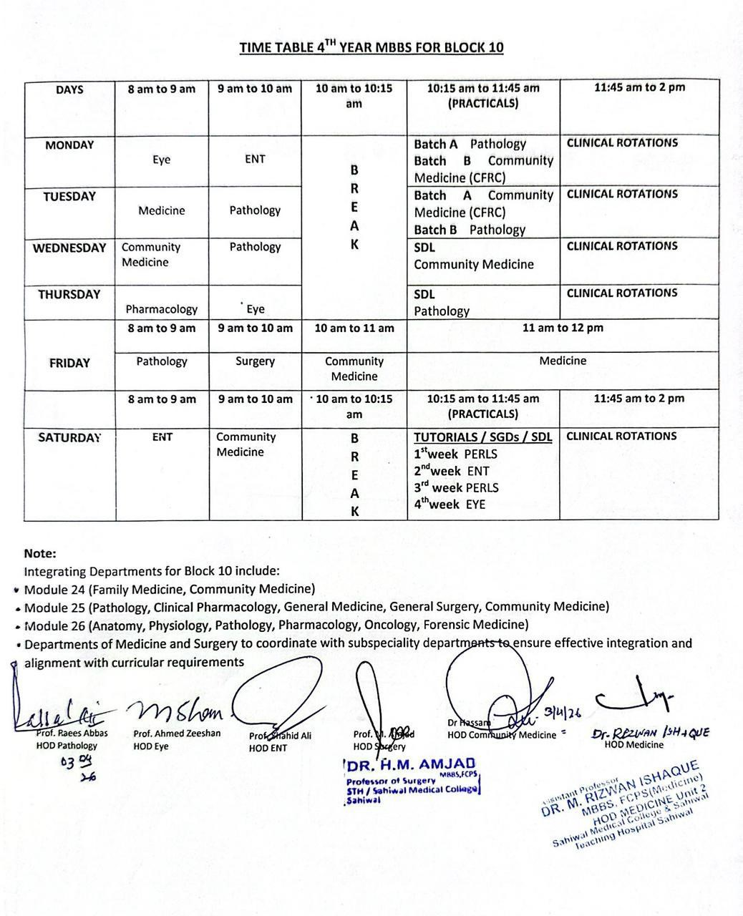

ACADAMIC CALENDER



