

Pediatric Surgery Study Guide

4Th Year

MODULAR INTEGRATED CURRICULUM 2K23
4TH Year

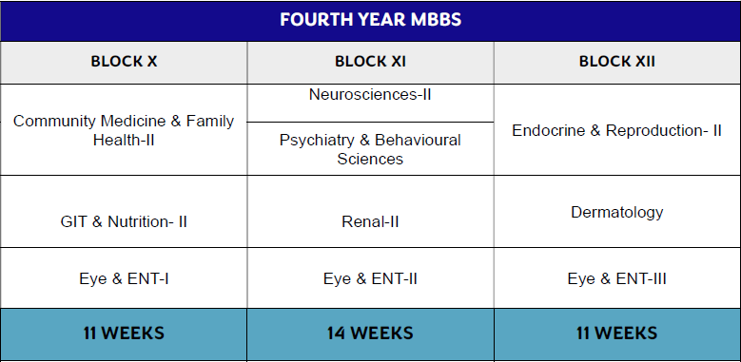



Duration: 11 Weeks No of Modules: 03
Module 24: Community Medicine & Family Health-II Module 25: GIT & Nutrition-II
Module 26: EYE & ENT-I

BLOCK 10 MANAGEMENT TEAM
HOD PAEDIATRIC SURGERY | Professor Dr Riaz-Ul-Haq
BLOCK COORDINATOR | Dr Wajeeha Chaudhry
4th YEAR MEMBERS | Dr Saba Tabbasum Dr Ali Raza  Dr Ali Raza Farooq  Dr Jafala Aslam

MODULE 26
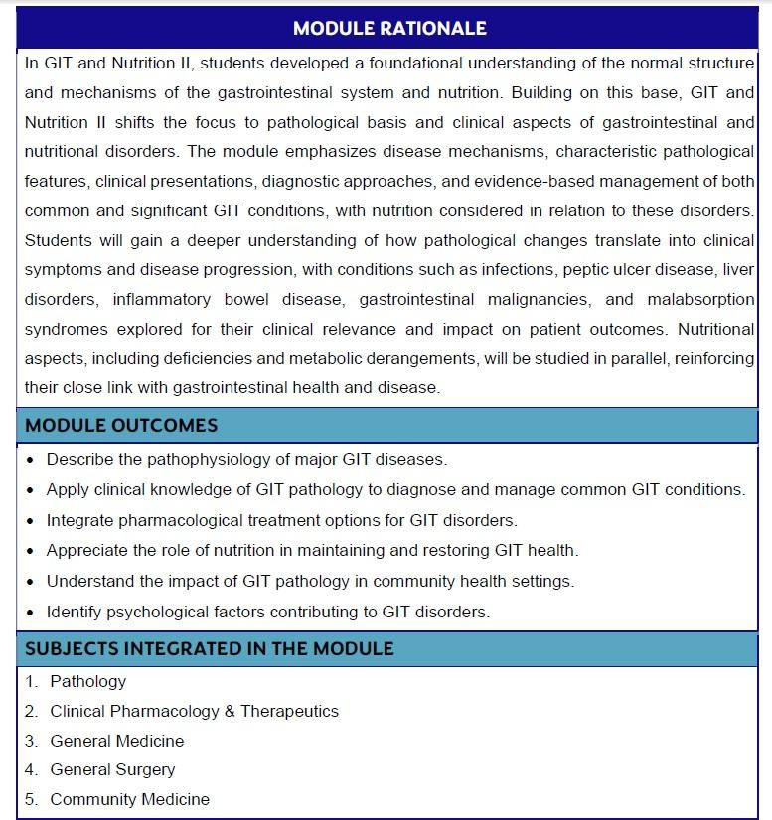

LEARNING OUTCOMES
SMALL AND LARGE INTESTINE

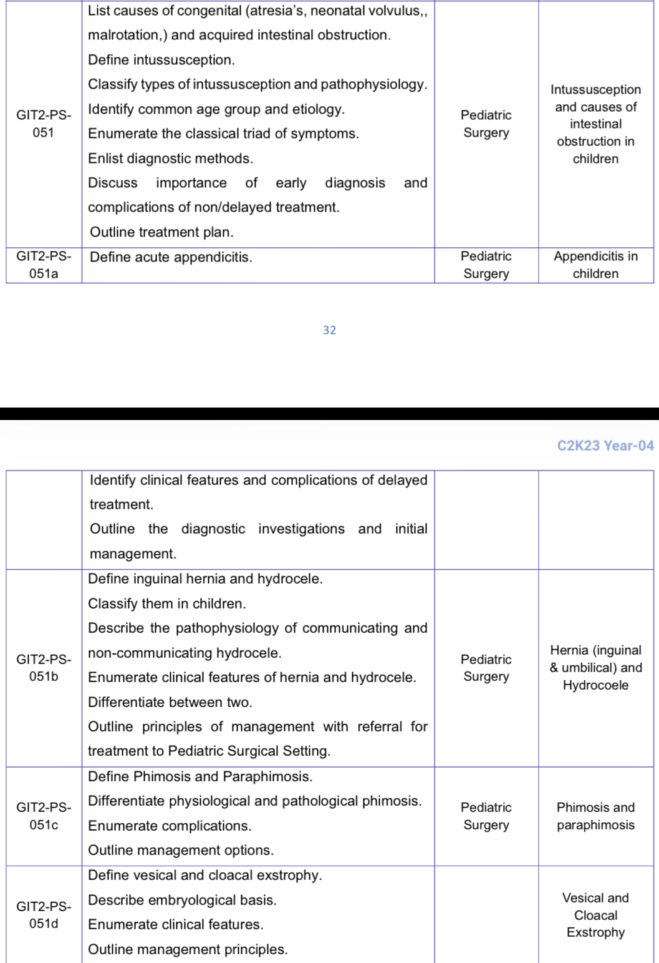

HEPATOBILIARY

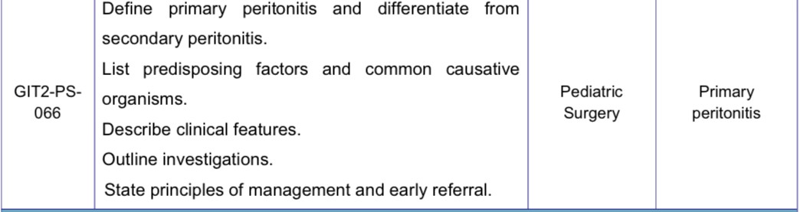

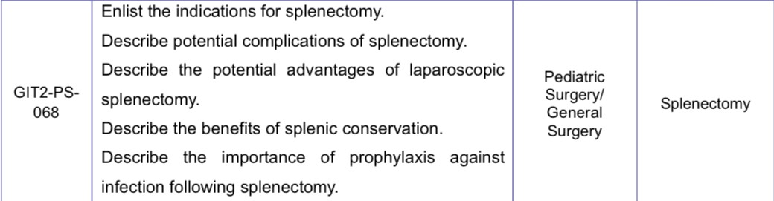
SPLEEN



Duration: 11 Weeks No of Modules: 04
Module 27: Neurosciences-II
Module 28: Psychiatry & Behavioral Sciences Module 29: Renal-II
Module 30: EYE & ENT-II

BLOCK 10 MANAGEMENT TEAM
HOD PAEDIATRIC SURGERY | Professor Dr Riaz-Ul-Haq
BLOCK COORDINATOR | Dr. Wajeeha Chaudhry
4th YEAR TEAM MEMBERS | Dr Saba Tabbasum Dr Ali Raza  Dr Ali Raza Farooq  Dr Jafala Aslam

MODULE NO. 27:
MODULE 27: Neurosciences -II
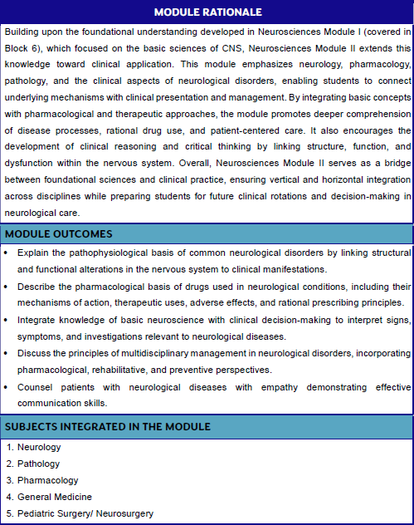

LEARNING OUTCOMES

NEUROSCIENCES

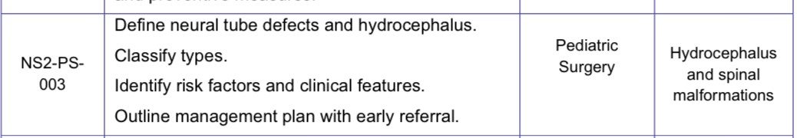

MODULE 29
MODULE 27: RENAL II

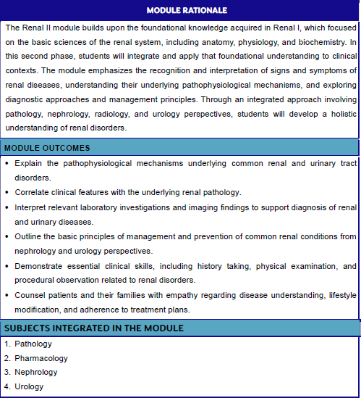

OBSTRUCTIVE AND INFECTIVE DISORDERS OF URINARY TRACT
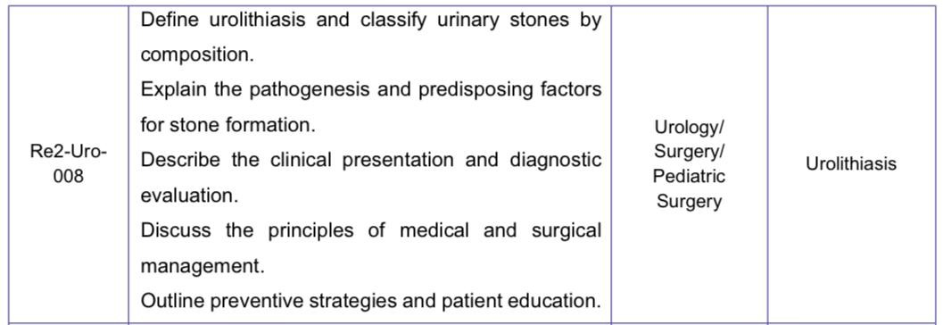
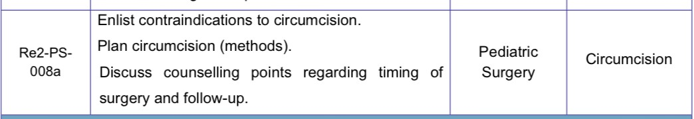
PROSTATE AND GENITOURINARY DISORDERS

Congenital Genitourinary Anomalies
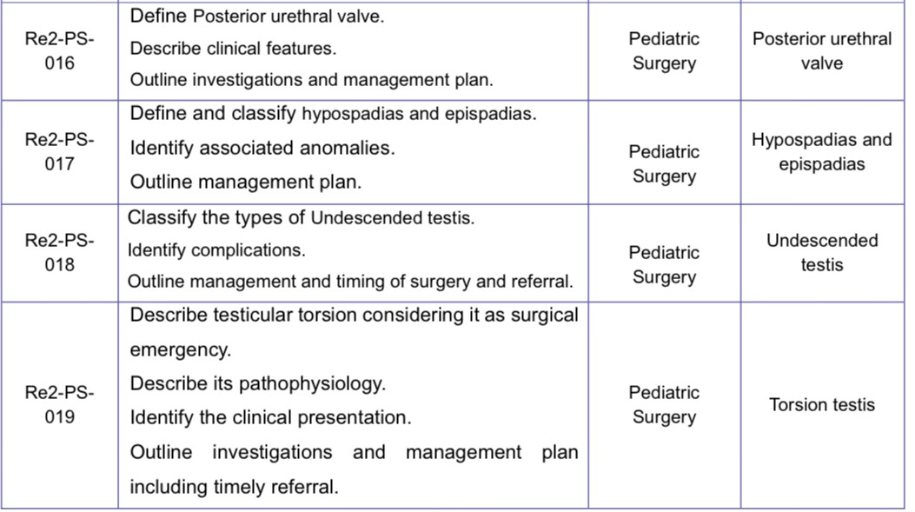

ASSESSMENT
Table Of Specifications

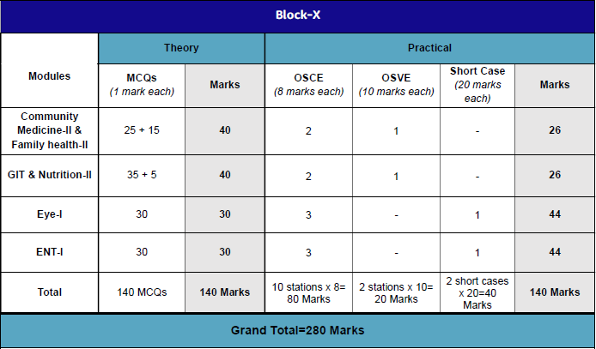

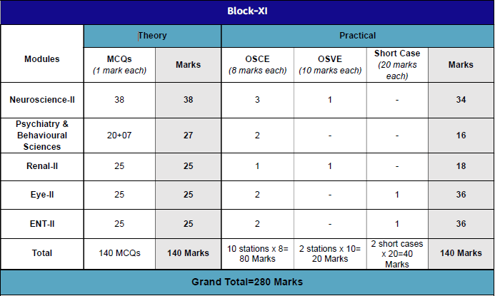
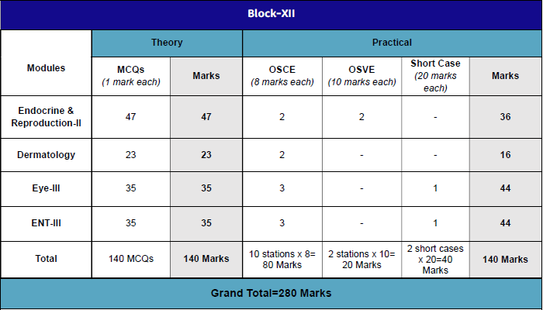

LEARNING RESOURCES

- Bailey and Love’s Short Practice of Surgery--- 28th Edition--- CRC Press ---- 2023
- Arnald G. Corn Pediatric Surgery 27th Edition

TIME TABLE
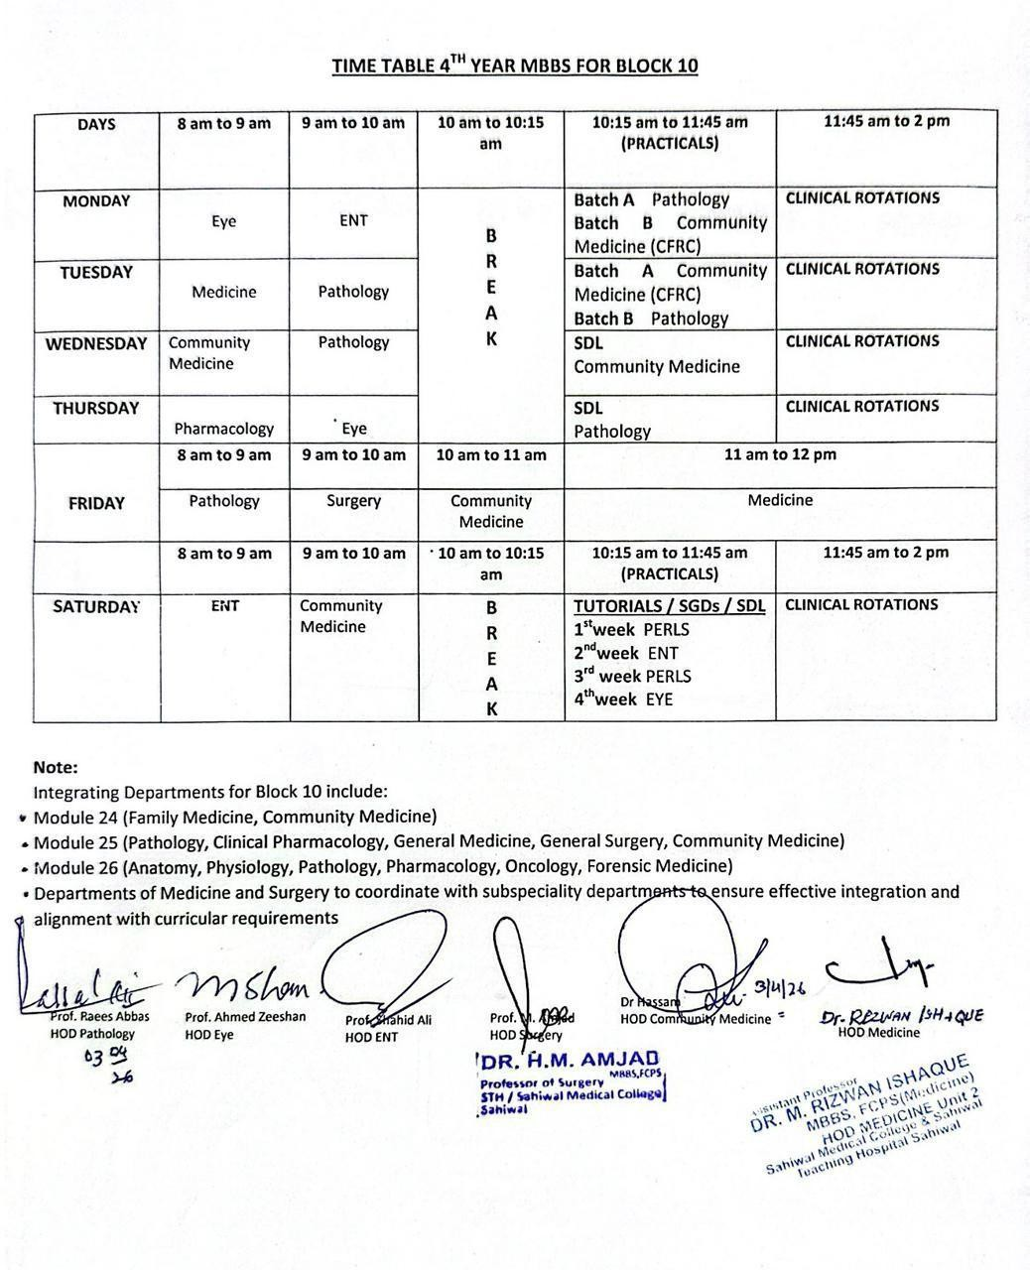

ACADAMIC CALENDER



